Policy Tracker Architecture: Website Integration Overview
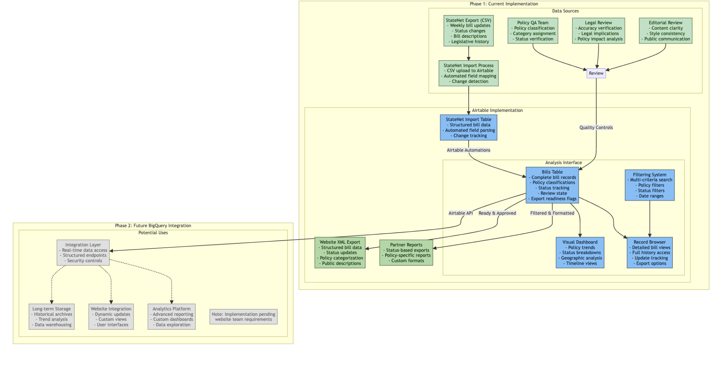

Current System (Phase 1)
We have implemented a policy tracking system in Airtable that processes legislative data through several stages:

1. Data Collection & Processing
- Weekly StateNet CSV imports
- Automated field mapping and change detection
- Multi-stage review process (Policy, Legal, Editorial)

2. Core Functions
- Structured bill data storage
- Policy classification system
- Status tracking
- Public content generation

3. Current Export Capabilities
- XML generation for website updates
- CSV exports possible if desired
- Partner-specific reports
- Analysis dashboard views

Integration Requirements

We need to understand:
- Your preferred XML schema and required fields
- Ideal update frequency and delivery method
- Any specific data format requirements
- Integration timeline preferences

Future Possibilities (Phase 2)
Once we understand your needs, we can explore:
- Direct API access through Airtable
- Real-time data updates
- Custom data views and filters
- Advanced analytics integration, including backups to BigQuery data warehouse

Next Steps
1. Review our current architecture
2. Share your XML requirements
3. Discuss integration preferences
4. Plan implementation timeline

